Working Capital for CEFIA-eligible Contractors

What is working capital?
Line of credit secured by ongoing cash flow / project finance / accounts receivable (e.g., your customers)

CEFIA’s Working Capital program
- Partnering with banks – Webster Bank is the first
- Borrow up to 50% of project costs for CEFIA program projects
- Interest rate = Webster Bank Prime Rate + 2%, floating (today = 5.25%)
- Webster Bank will confirm project with CEFIA

Application requirements

  - Webster Bank Business Banking Application
  - CEFIA financial product being used (Smart-E, CT Solar Lease, CT Solar Loan, Cozy Home loan) and CEFIA-approved contractor certificate
  - Project address (if requesting funds with 1st application)
  - Project amount (if requesting funds with 1st application)
  - Most recent business tax return [only for first Working Capital application]
  - Most recent business balance sheet [only for first Working Capital application]

Contact
To learn more or discuss working capital for your business, contact:

Frank Mac Hugh, V.P. of Business Banking
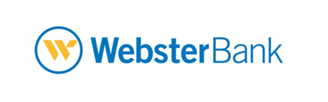
Business: (860) 692-1607
Mobile: (860) 480-6433
Fmachugh@websterbank.com

Total project amounts >$50k will require 2 years of tax returns

